**TUGAS**

1. Penguatan sinyal

T=100;

t=0:1/T:2;

f1=1;

y1=sin(2*pi*t);

subplot(2,1,1)

plot(t,y1)

a=input('nilai pengali yang anda gunakan (> 0): ');

y1_kuat=a*sin(2*pi*t);

subplot(2,1,2)

plot(t,y1_kuat)

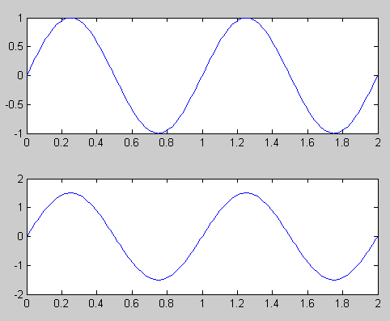

1. Pelemahan sinyal, nilai penguatannya bernilai 1 sehingga sinyal akan sama bentuknya atau melemah

T=100;

t=0:1/T:2;

f1=1;

y1=sin(2*pi*t);

subplot(2,1,1)

plot(t,y1)

a=input('nilai pengali yang anda gunakan (> 0): ');

y1_kuat=a*sin(2*pi*t);

subplot(2,1,2)

plot(t,y1_kuat)

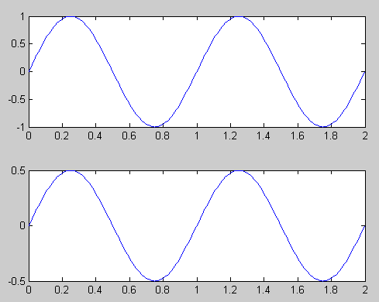

1. Penjumlahan sinyal

T=100;

t=0:1/T:2;

f1=1;

y1=sin(2*pi*t);

subplot(3,1,1)

plot(t,y1)

f2=2;

pha2=pi/2;

y2=sin(2*pi*t+pi);

subplot(3,1,2)

plot(t,y2)

T=100;

t=0:1/T:2;

f1=1;

f2=2;

pha2=pi/2;

y1=sin(f1*pi*t);

subplot(3,1,1)

plot(t,y1)

y2=sin(f2*pi*t+ pha2);

subplot(3,1,2)

plot(t,y2)

y3=y1+y2;

subplot(3,1,3)

plot(t,y3)

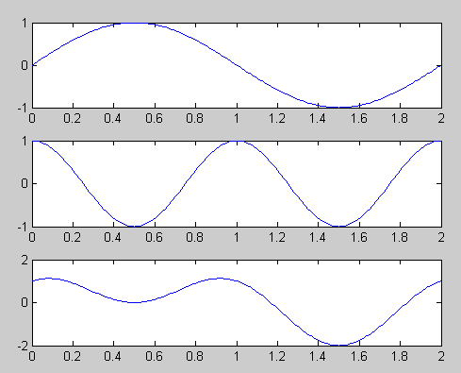

1. Perkalian sinyal

T=100;

t=0:1/T:2;

f1=1;

f2=2;

pha2=pi/2;

y1=sin(f1*pi*t);

subplot(3,1,1)

plot(t,y1)

y2=sin(f2*pi*t+ pha2);

subplot(3,1,2)

plot(t,y2)

y3=y1.*y2;

subplot(3,1,3)

plot(t,y3)

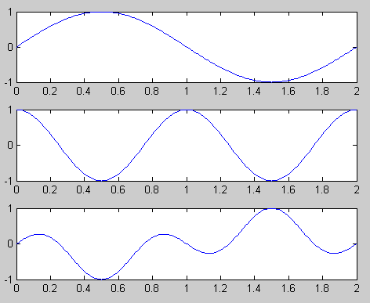

1. Penambahan noise gaussian pada sinyal audio

y1=wavread('botak.wav');

Fs=8192;

Fs1 = Fs;

t=1:tt;

wavplay(y1,Fs1,'sync')

subplot (2,1,1), plot (t,y1)

N=length(y1);

var = 0.1;

noise_1=var*randn(N,1);

y_1n=y1 + noise_1;

wavplay(y_1n,Fs1,'sync')

subplot (2,1,2), plot (t,y_1n)

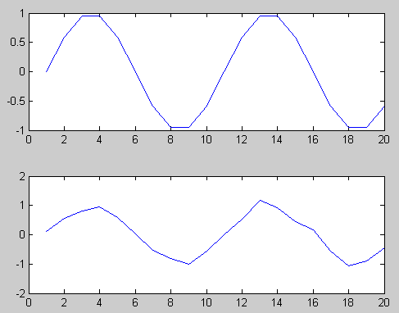

1. Proses penguatan pada sinyal audio

y1=wavread('botak.wav');

Fs=8192;

wavplay(y1,Fs,'async')

amp =1.5;

y2=amp*y1;

wavplay(y1,Fs,'async')

t=1:tt;

subplot (2,1,1), plot (t,y1)

subplot (2,1,2),plot (t,y2)

